- A series of problems have undermined confidence in the accuracy of official economic statistics for the UK. When using Office for National Statistics data, it's important that users make allowance for the increased uncertainty about their reliability.
- As well as the well-publicised problems with the ONS Labour Force Survey and population estimates, trade and producer prices releases have had to be postponed recently. Other problems are emerging that are yet to be officially acknowledged, including volatility in GDP and retail sales data that are indicative of problems related to seasonal adjustments.
- Big structural changes, such as rapid adoption of AI, are increasing the challenges statisticians face. In future, official data series may be less reliable, more volatile, and more prone to revision.
- We also advocate users consider a wider variety of sources, such as our sentiment-based nowcasts, to understand where the risks in official data lie.
In January, we examined problems with the Office for National Statistics' flagship Labour Force Survey and associated issues with its population estimates. But it's becoming increasingly clear that this is just the tip of the iceberg and the problems with official data are more widespread. Table 1 summarises the issues that have caused the ONS to suspend, postpone, or heavily revise macroeconomic data in recent years.
Table 1: Problems with key official economic data in recent years
Indicator | Issue
Labour Force Survey | Survey response rates collapsed from nearly 50% in 2013 to just 12.7% in Q3 2023, with even lower response rates among some groups. This meant results were not representative and became very volatile. Efforts to increase response rates have yielded only modest success, and the ONS has stated it may take until 2027 for the problems to be fixed.
Population estimates | The International Passenger Survey, the main source of migration data, was suspended during the pandemic. Progress towards a permanent replacement has been slow and a series of methodological improvements have led to regular revisions to population estimates. This has also caused revisions to labour market series, with more revisions to come when the latest – much higher – immigration estimates are incorporated.
Trade data | The UK Statistics Authority suspended the National Statistics (quality standard) designation for the monthly trade release in 2014, and it is yet to be reinstated. In addition, data collection changes introduced a structural break in all trade series in 2021.
Services exports and imports | Publication of the March 2025 trade release was delayed by two weeks following discovery of a "processing error" that's likely to have caused the level of services exports and imports to be understated by 2%-6% between 2023-2024.
Producer prices | After discovering a problem with its chain-linking methods, the ONS has postponed the next release due on March 26, and has warned producer output price inflation will likely be revised upwards, particularly for 2022 and 2023. This will also impact sectoral GVA and trade estimates.
Average weekly earnings | The ONS has said that as an exception to its normal practice, it will revise historical data to allow for updated and late returns from one business.
Source: Oxford Economics

On top of the problems the ONS has acknowledged, in two other high-profile areas there has been strong criticism of their methods from experts.
First, the ONS recently made three methodological changes to its measurement of household wealth. One partially corrected an error in how inflation is accounted for in valuing pensions, reducing the level of household wealth in 2018-2020 by 14%. But the Institute for Fiscal Studies has argued the methodological changes have introduced a new error in the way the value of future pension income is converted into today’s terms.
Second, in recent testimony to the Treasury Select Committee, Bank of England Governor Andrew Bailey pointed to estimates that total public sector productivity is 8%-9% below its 2019 level and that health productivity is 17%-18% lower. The Governor said these estimates were "striking and puzzling". While at pains to state that he was not an expert in this area, there was a clear implication that he found the estimates hard to rationalise. That the National Statistician is undertaking an independent review of the measurement of public services productivity also points to problems.

Issues with other ONS series
We also have suspicions about several other ONS data series. Both the GDP and retail sales series appear to be suffering from residual seasonality, potentially reflecting changes to spending patterns since the pandemic.
For GDP, since 2022 there's been stronger momentum in H1 of each year, followed by an abrupt slowdown in Q3 (Chart 1). Given the monthly data already available, there's a good chance this pattern will be repeated this year. This pattern is becoming too regular to be a coincidence.
Chart 1: GDP data is consistently showing a Q3 slowdown after strong H1s
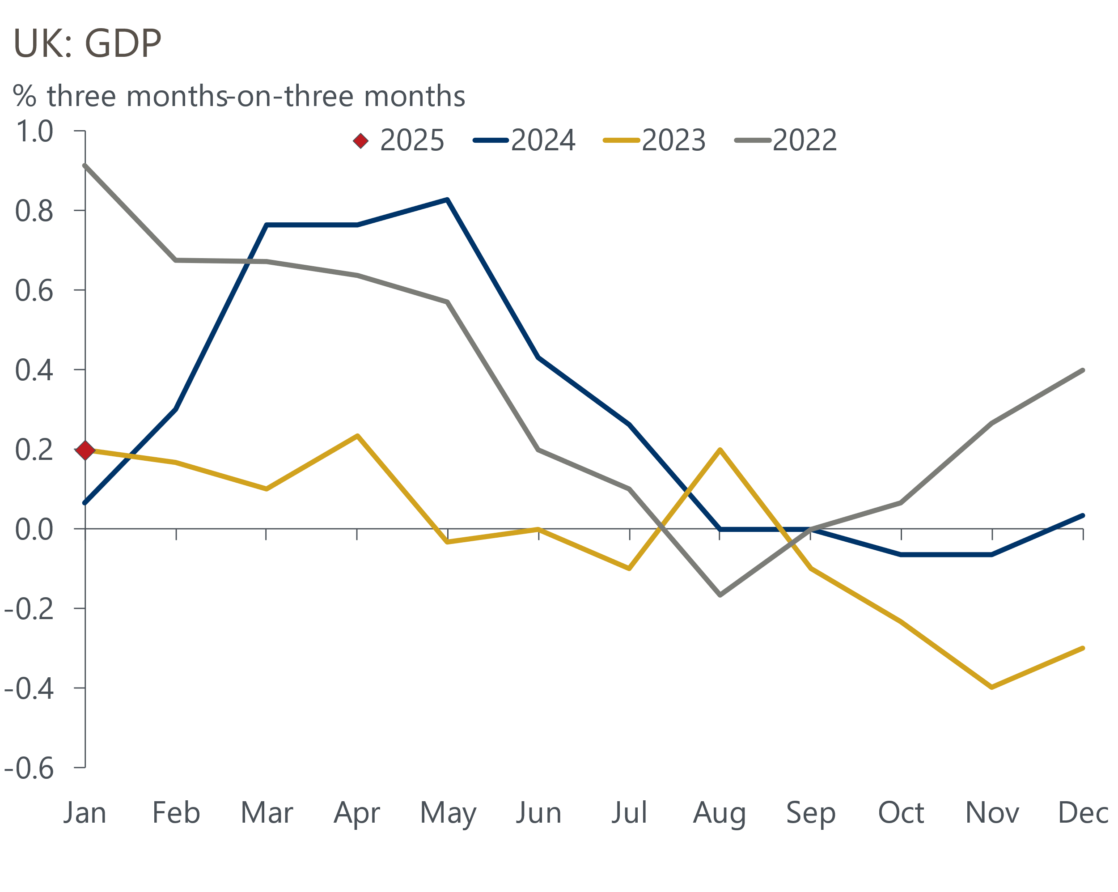
Source: Haver Analytics
Regarding retail sales, in each of the past two years sales in food stores have slumped in December, followed by a sharp upturn in January (Chart 2). Food sales are highly seasonal – on a non-seasonally adjusted basis, sales in December are around 2.5% higher than the average month and sales in January are just over 1% lower. This means the ONS is applying relatively large seasonal adjustment factors to the raw data, and small changes in the seasonal pattern of sales can cause large swings in the final seasonally adjusted series.
Chart 2: Sales in food stores appear to be subject to residual seasonality around the turn of the year
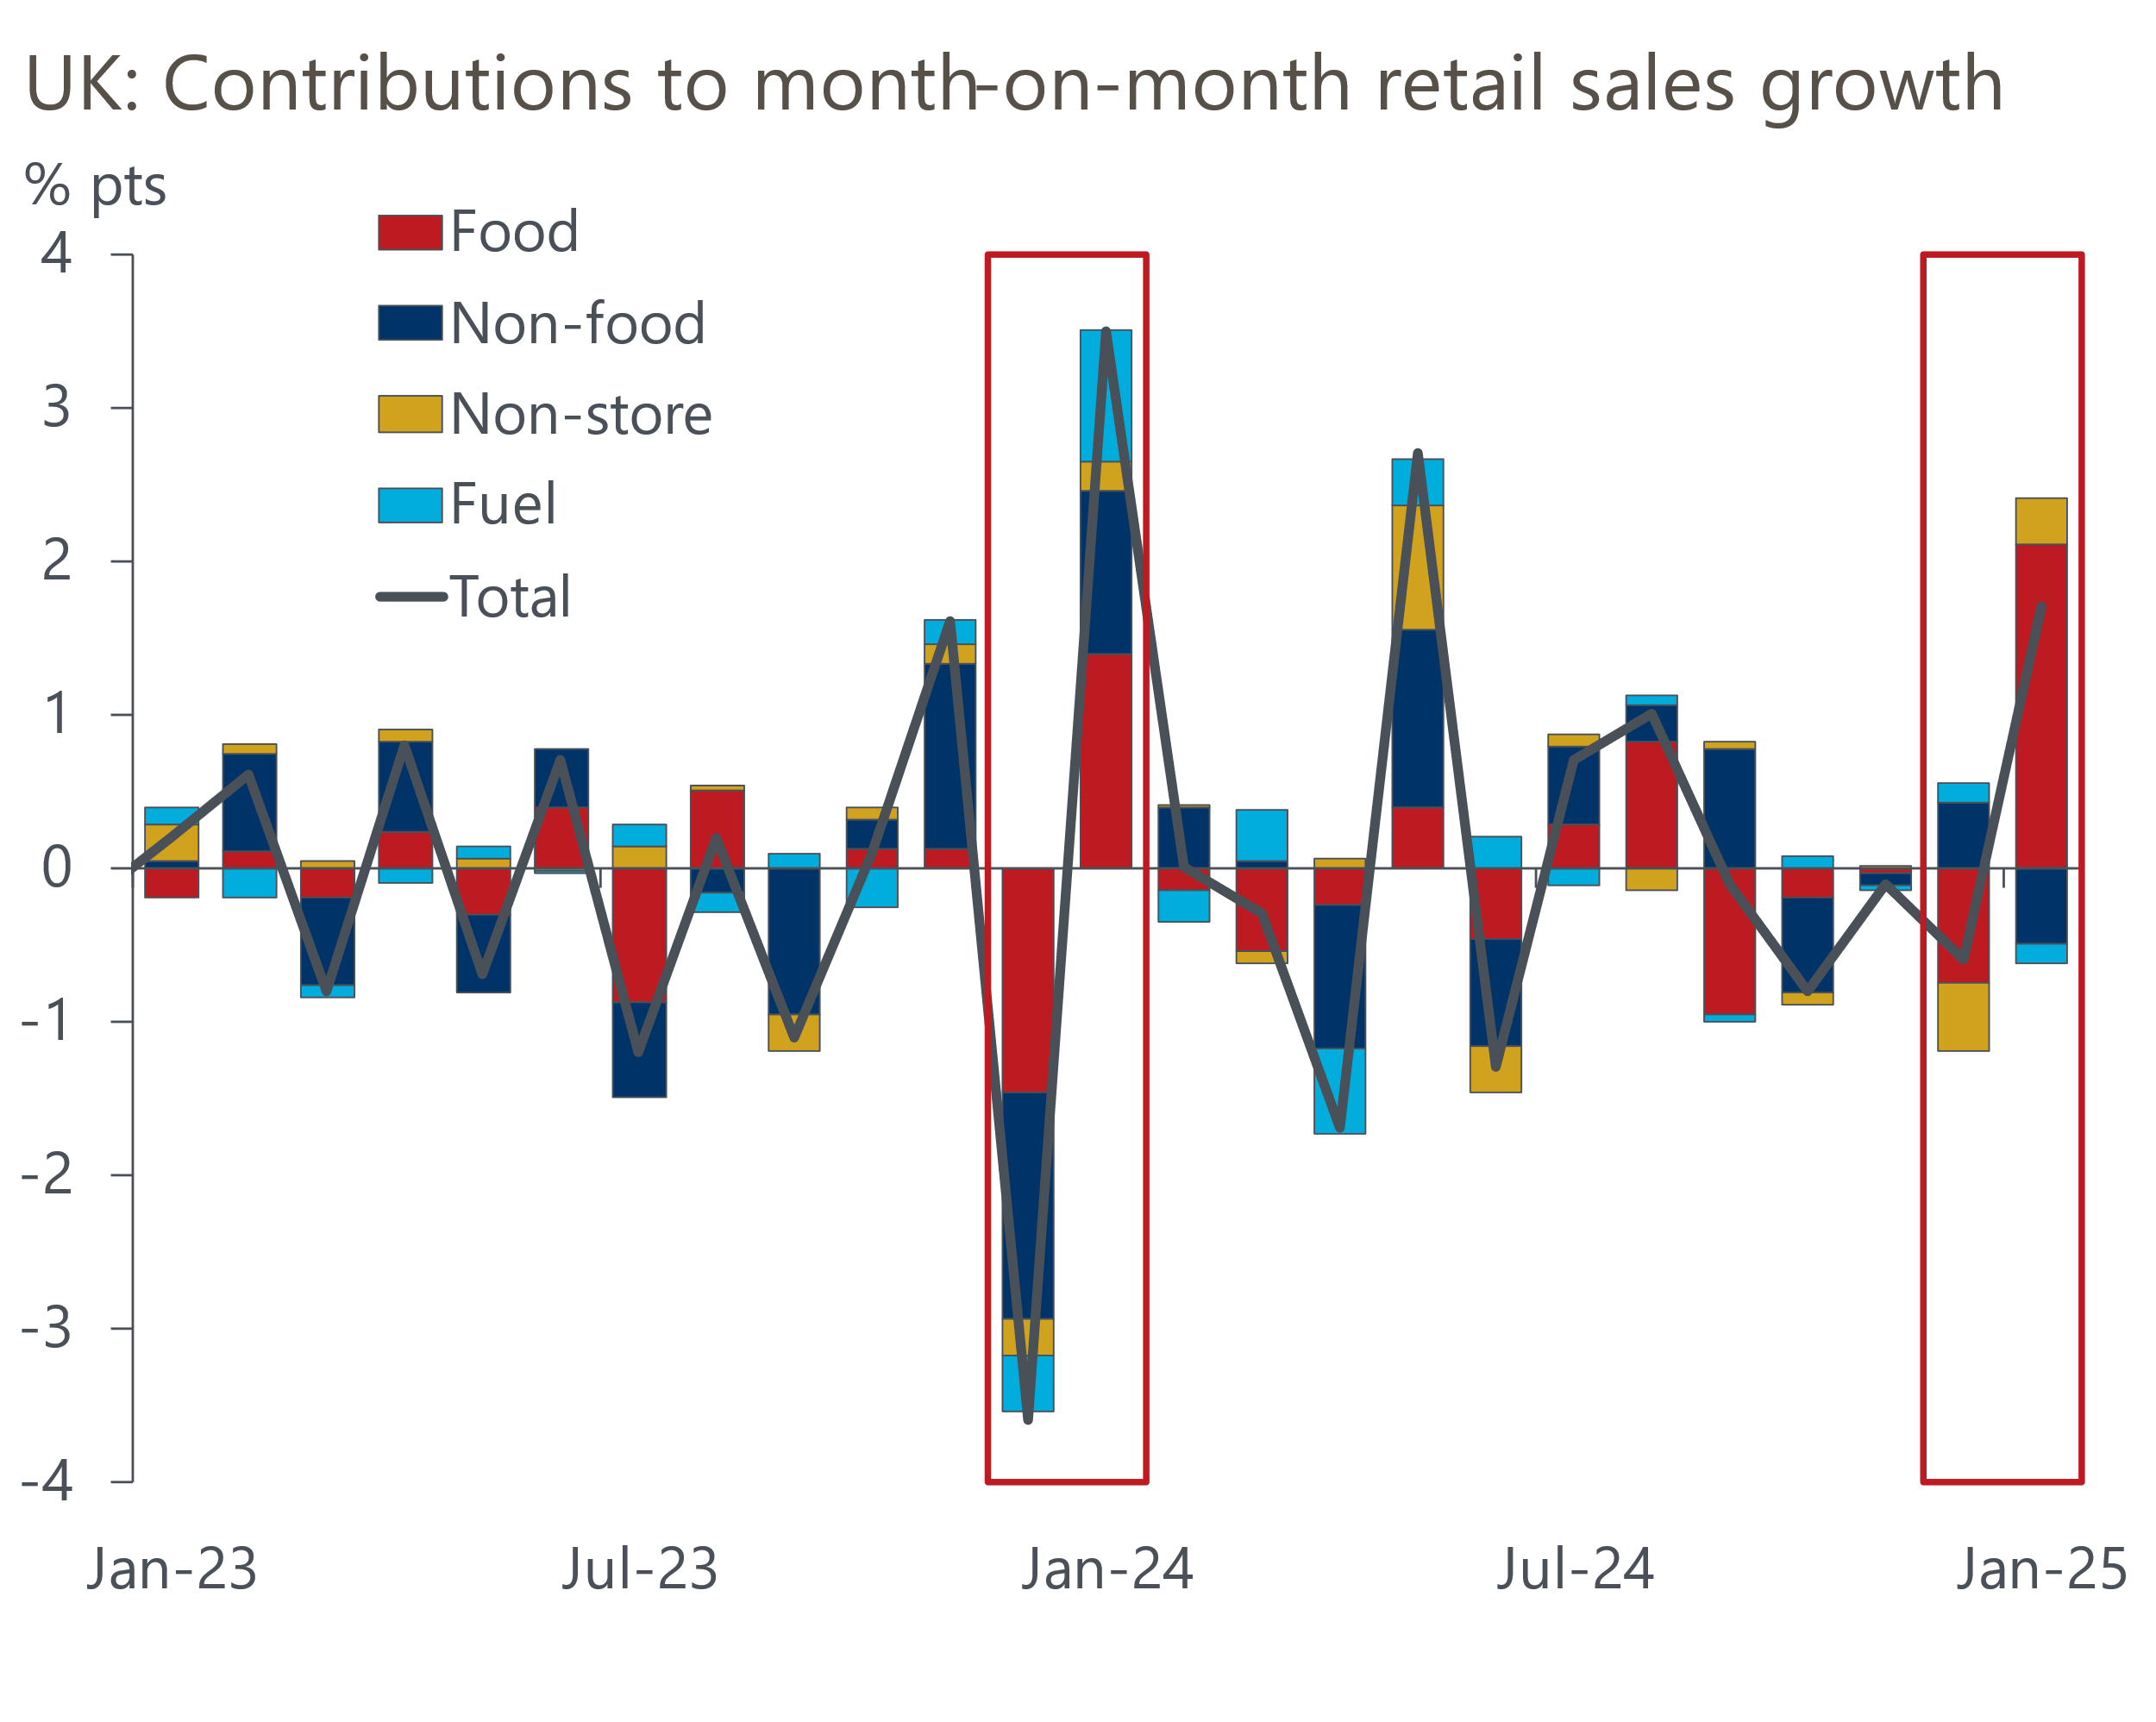
Source: Haver Analytics
Issues with the official measures of pay are also cropping up. Headline (three-month average of the annual rate) private sector regular pay growth has strengthened from below 5% in early autumn to above 6% in the latest data. Base and compositional effects can only explain some of the pickup. By contrast, survey-based measures of pay growth have been on a downward trend over the past year (Chart 3). Our proprietary high-frequency sentiment dataset, developed in collaboration with Penta, has also signalled softer trends in pay growth than the official measure.
Chart 3: The official pay data has been strengthening, in contrast to other measures
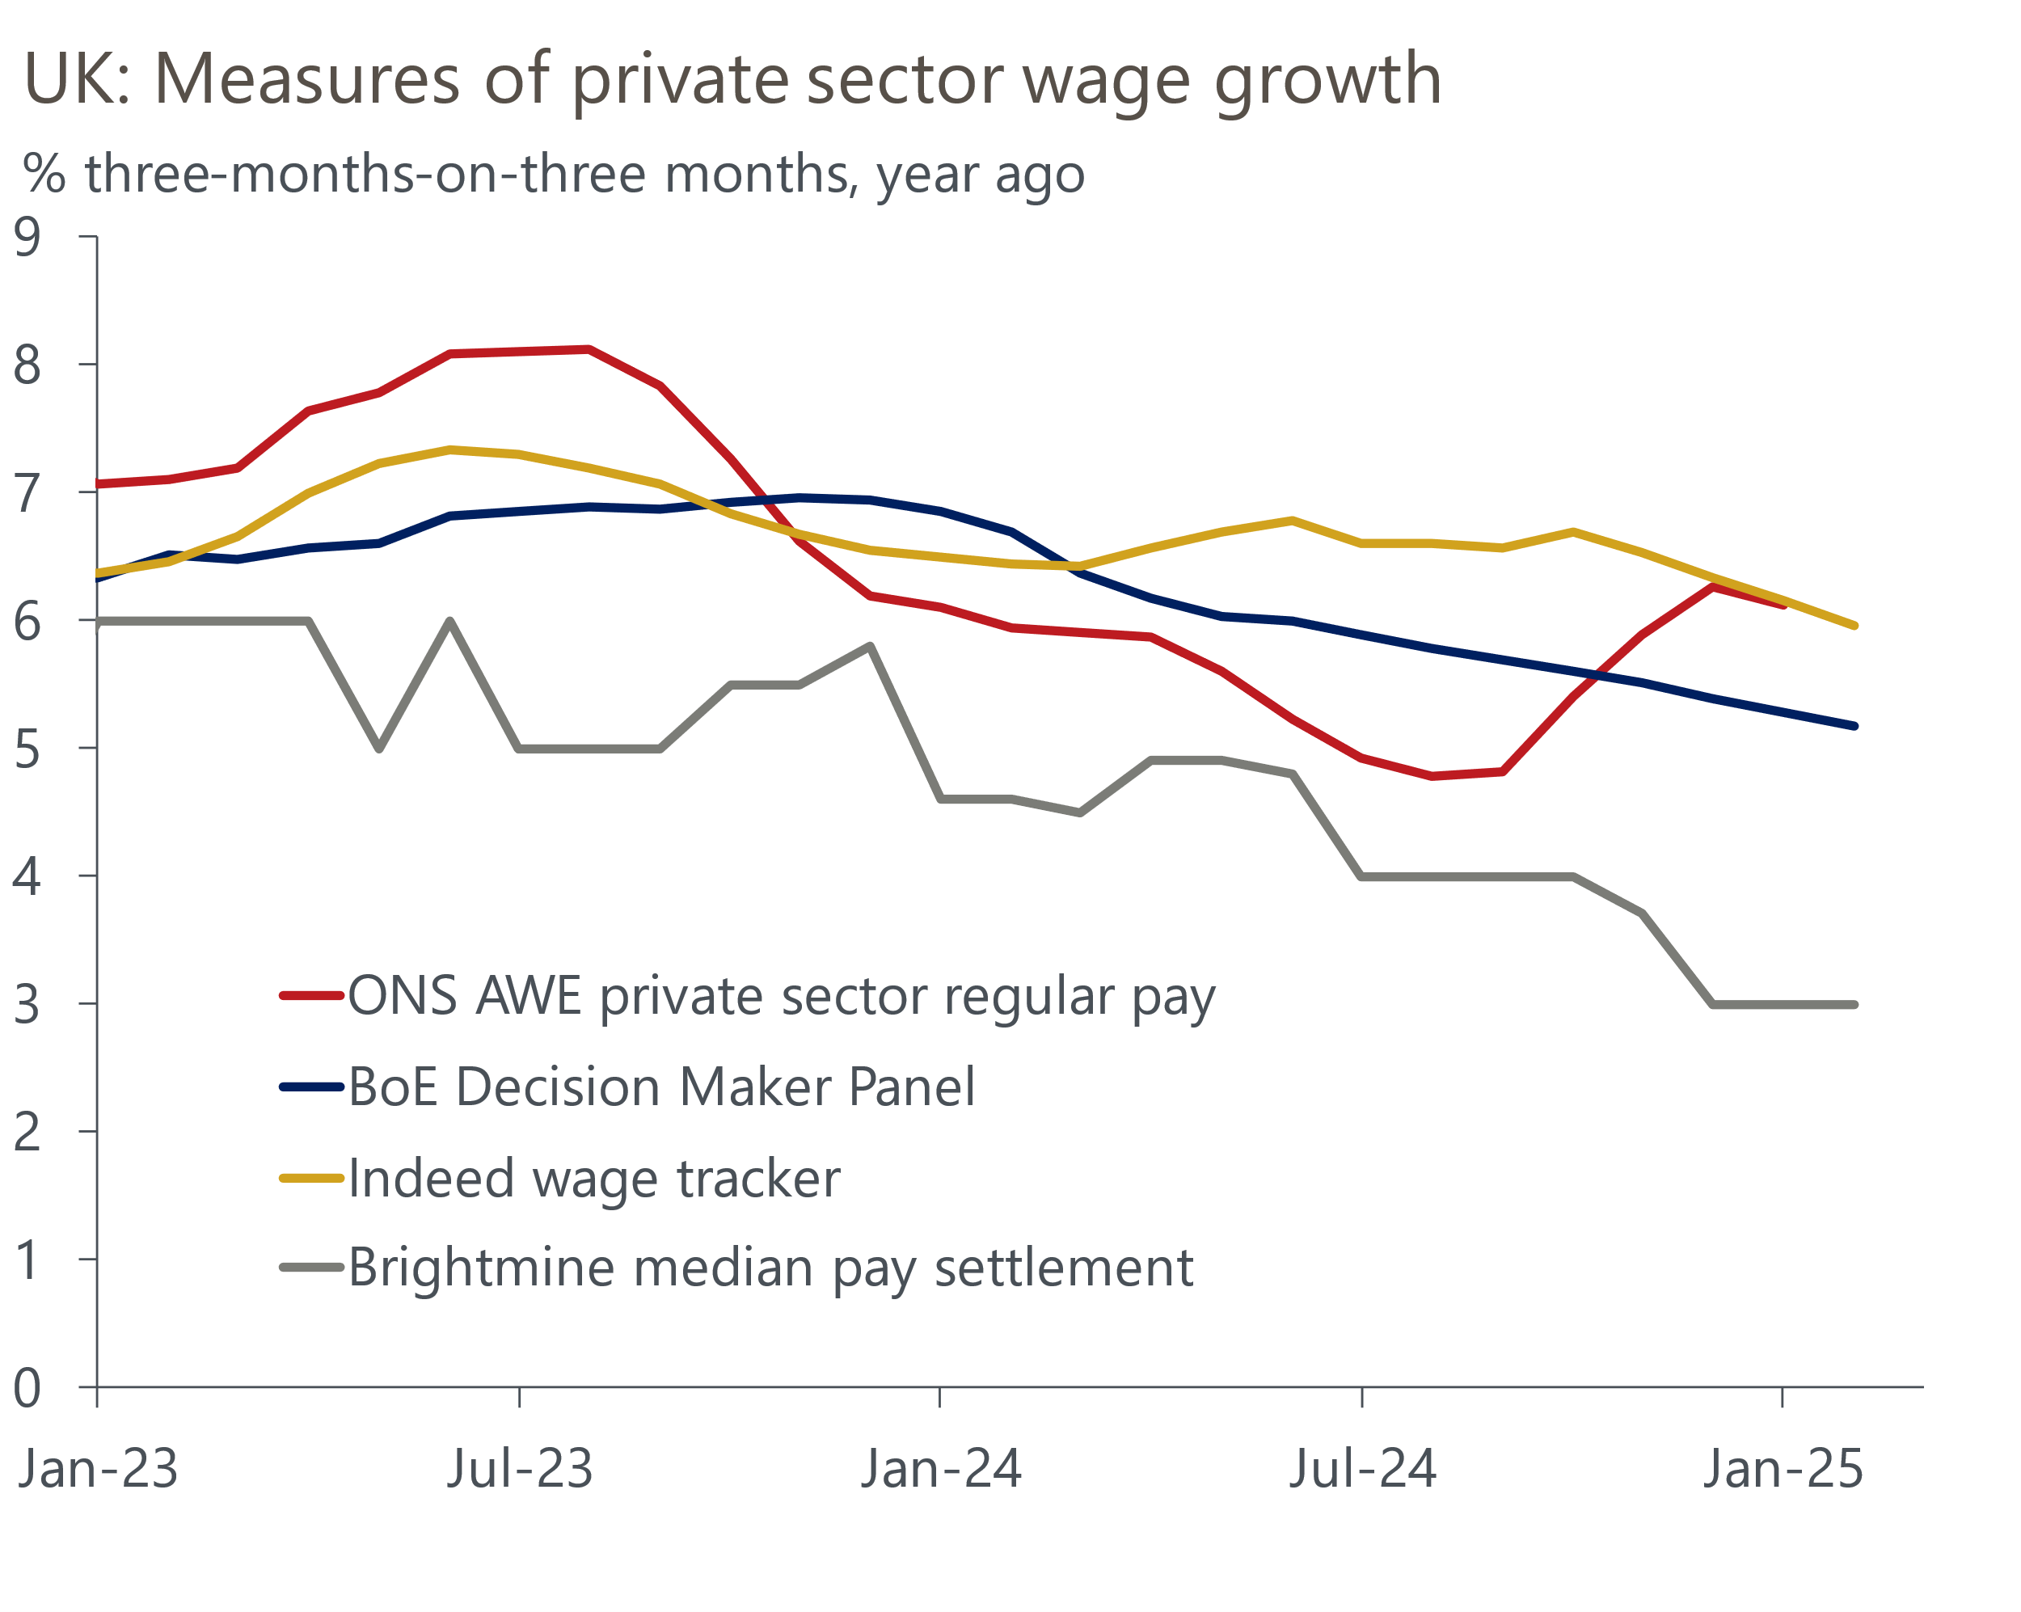
Source: Haver Analytics
The ONS has flagged it plans to revise its average weekly earnings series at some point to incorporate updated and late returns from one employer. It's not clear whether this will mean pay growth is revised up or down. But the fact that the ONS has drawn attention to the issue in its monthly publication and the BoE referenced it in the minutes of its March meeting suggest the impact of the revisions will be material.
It's possible that the employer might be the government, particularly given there's been no obvious impact on the data from the 5%-6% pay settlements signed off by the Chancellor shortly after taking office.

Funding shortages and organisational lethargy may be the main root causes
The UK is far from the only country experiencing data problems – our US colleagues recently wrote about issues with US economic data. But the problems in the UK seem to be the most acute. Nor is this a new issue – worries about the coverage and reliability of official statistics have been around for decades. But our impression is that things have gotten worse in recent years.
Key problems appear to be a shortage of funding and a lack of dynamism within the ONS. The organisation has been slow to respond to changes in the world around it. The 2016 Bean Review identified this as a problem and recommended ways to address it, but there's scant evidence that the ONS has taken these on board. These challenges are only likely to grow as the economy undergoes large structural changes, such as the rapid adoption of artificial intelligence.
The ONS has also been slow to respond to some of the specific problems. In the case of the Labour Force Survey, response rates had been drifting downward for many years before the pandemic. But response rates started to plummet after social distancing restrictions caused a switch from face-to-face interviews to phone surveys. The ONS recognised the problem and began work on a replacement, the Transformed Labour Force Survey. But progress was so slow that – three-and-a-half years after the start of the pandemic – the ONS had to suspend publication of LFS results for five months because it was so concerned about the validity of the data and the replacement survey wasn't ready.
When it suspended the LFS in October 2023, the ONS expected the TLFS to be "the primary source for the labour market release in March 2024." But that timetable has progressively slipped. Now the ONS says that transitioning to TLFS in mid-2025 is "unlikely" and it aims to complete the process in 2027. If the proposed timetable holds, the UK will endure a four-year period without reliable data for its key labour market series.
Some of the problems would likely be alleviated if the ONS relied less on surveys. Prior to the pandemic, the ONS was keen to overhaul its data collection methods to make more use of 'big data'. But there's few signs that this project has progressed. In recent testimony to the Treasury Select Committee, National Statistician Professor Sir Ian Diamond suggested this was because government departments were unwilling to share data. In areas where some progress on modernisation has been made, for example with the use of supermarket scanner data in the compilation of the inflation statistics, full implementation has been delayed.

Users should treat official data with care
Noisy and revision-prone data cause major problems for policymakers. Some of the areas of highest policy interest currently are those most affected by sub-standard data. For example, if the US levies higher tariffs on imports from the UK, the impact will be hard to judge given ongoing problems with trade data. Meanwhile, the unreliable LFS will make it hard to assess the impact of the increase in employers' national insurance contributions on the labour market.
Uncertainties over the accuracy of official data also make it harder for the BoE's Monetary Policy Committee to fulfil its inflation remit. The unexpected strengthening in the official measure of pay growth has caused some members of the MPC to question their previous judgements on how persistent inflationary pressures will prove to be. If pay growth strength is subsequently revised away, then data problems could be a key contributor to a policy error.
For data users, it's important that they make allowance for greater uncertainty around the validity of official statistics. Incorporating a broader range of data sources, including alternative sources such as our high-frequency sentiment dataset, is one way of doing this. Being aware of the sensitivities of economic models to the series that come with major question marks is also important.
Our own macroeconomic forecasts are dependent on these ONS series as inputs – a key principle of our methodology is to use official data as it's published to maintain consistency. However, we aim to be clear in our accompanying commentary if we believe there are doubts about the validity of the data, and to use an array of alternative data – including those we have developed with Penta and Data City – to assess where the risks lie.
Overall, users should be aware that there is a greater risk of large revisions to historical data as the ONS tries to rectify the problems it uncovers. And where the solution involves switching data source, as is the case with the Labour Force Survey, this risks introducing a structural break into the time series.

